Tau Kappa Epsilon
3.9
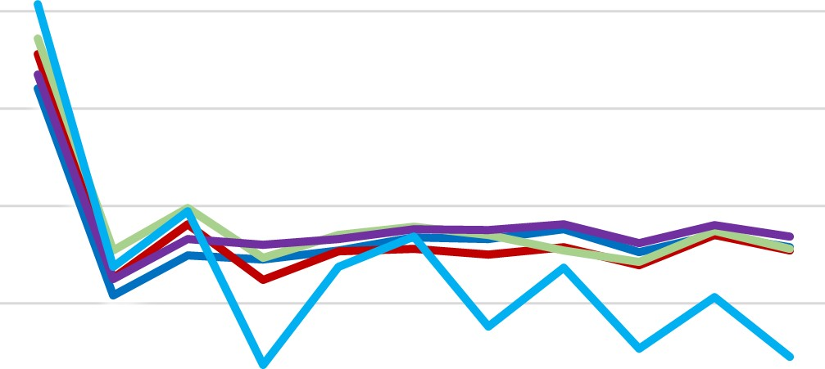
  All Male
  —All IFC
  All Greek
  All Student
  —Tau Kappa Epsilon
3.7
3.5
3.3
3.1
2.9
2.7

S20 F20 S21 F21 S22 F22 S23 F23 S24 F24 S25

